**Router Basic and Password Configuration**

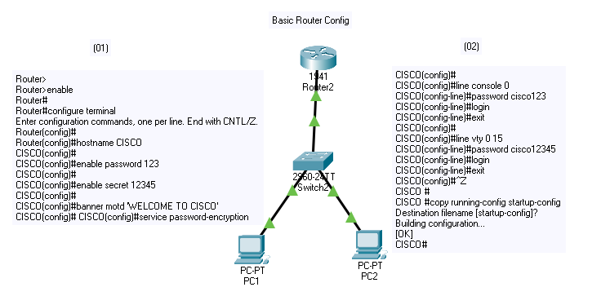

Router> **(User Executive Mode)**

Router>enable

Router# **(Privileged Mode)**

Router#configure terminal

Enter configuration commands, one per line. End with CNTL/Z.

Router(config)# **(Global Configuration Mode)**

Router(config)#hostname CISCO **(To Set Hostname)**

CISCO(config)#

CISCO(config)#enable password 123 **( To Set Password for Configuration)**

CISCO(config)#

CISCO(config)#enable secret 12345 **( To Set Secret ‘password’ for Configure above Password)**

CISCO(config)#

CISCO(config)#banner motd 'WELCOME TO CISCO' **(Set Welcome Message)**

CISCO(config)#

CISCO(config)#service password-encryption

CISCO(config)#

CISCO(config)#line console 0 **(To set password in console post)**

CISCO(config-line)#password cisco123 **(write password as you want)**

CISCO(config-line)#login **(Write ‘login’ command to activate password)**

CISCO(config-line)#exit **( for go back)**

CISCO(config)#

CISCO(config)#line vty 0 15 **(To set password for remote access or config)**

CISCO(config-line)#password cisco12345 **(Write password as you want)**

CISCO(config-line)#login **(Write ‘login’ command to activate password)**

CISCO(config-line)#exit **( for go back)**

CISCO(config)#^Z **( for go back in privileged mode)**

CISCO #

CISCO #copy running-config startup-config **(To save configuration)**

Destination filename [startup-config]?

Building configuration...

[OK]

**Router Basic and IP Address Configuration**

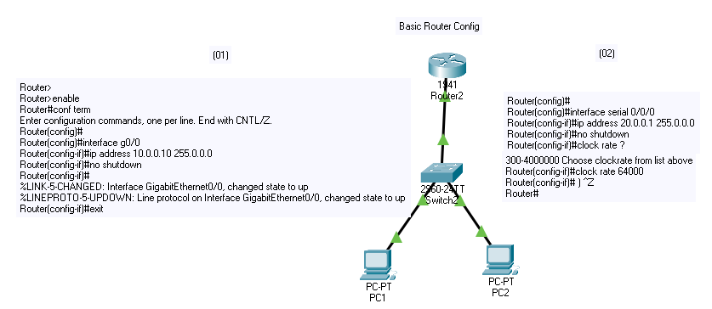

Router>

Router>enable

Router#conf term

Enter configuration commands, one per line. End with CNTL/Z.

Router(config)#

Router(config)#interface gigabitEthernet0/0 **(Select the port interface for configuration)**

Router(config-if)#ip address 10.0.0.10 255.0.0.0 **(Provide IP Address to port interface which you selected)**

Router(config-if)#no shutdown **(Use this command to activate port interface)**

Router(config-if)#exit

Router(config)#

Router(config)#interface serial 0/0/0 **(Select the port interface for configuration)**

Router(config-if)#ip address 20.0.0.1 255.0.0.0 **(Provide IP Address to port interface which you selected)**

Router(config-if)#no shutdown **(Use this command to activate port interface)**

Router(config-if)#clock rate ? **(must set clock rate ‘64000’)**

Speed (bits per second

1200

2400

4800

9600

19200

38400

56000

64000

72000

And etc upto 4000000

<300-4000000> Choose clockrate from list above

Router(config-if)#clock rate 64000 **(must set clock rate ‘64000’)**

Router(config-if)# ) ^Z

Router#

%SYS-5-CONFIG_I: Configured from console by console

Router#wr

Router#write **(To save configuration)**

Building configuration...[OK]

**Router Configuration and How to Remove/ Delete**

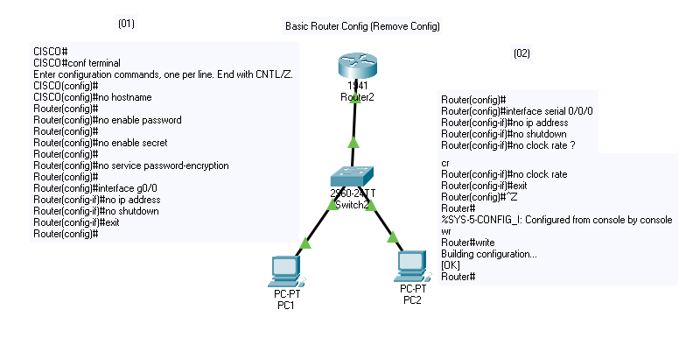

CISCO#

CISCO#conf terminal

Enter configuration commands, one per line. End with CNTL/Z.

CISCO(config)#

CISCO(config)#no hostname **(To remove hostname)**

Router(config)#

Router(config)#no enable password **(To remove enable password)**

Router(config)#

Router(config)#no enable secret **(To remove enable secret)**

Router(config)#

Router(config)#no service password-encryption **(To remove service password-encryption)**

Router(config)#

Router(config)#interface g0/0

Router(config-if)#no ip address **(To remove port ip address)**

Router(config-if)#no shutdown  **(To Active the configuration)**

Router(config-if)#exit

Router(config)#

Router(config)#interface serial 0/0/0

Router(config-if)#no ip address **(To remove port ip address)**

Router(config-if)#no shutdown **(To Active the configuration)**

Router(config-if)#no clock rate ? **(To remove the clock rate which you have set)**

<cr>

Router(config-if)#no clock rate **(To remove the clock rate which you have set)**

Router(config-if)#exit

Router(config)#

Router(config)#line console 0 **(Select Console port for configuration)**

Router(config-line)#no password **(Remove Password)**

Router(config-line)#exit

Router(config)#line vty 0 15 **(Select for configuration)**

Router(config-line)#no password **(Remove Password)**

Router(config-line)# ^Z

Router#write **(To save all configuration)**

Building configuration...[OK